Phase 5

Lesson 3

**Deploy Application on Cloud**

**Steps to deploy application on cloud:**

**Step 1:** create an ec2 instance.

* Go to aws console and select launch instances

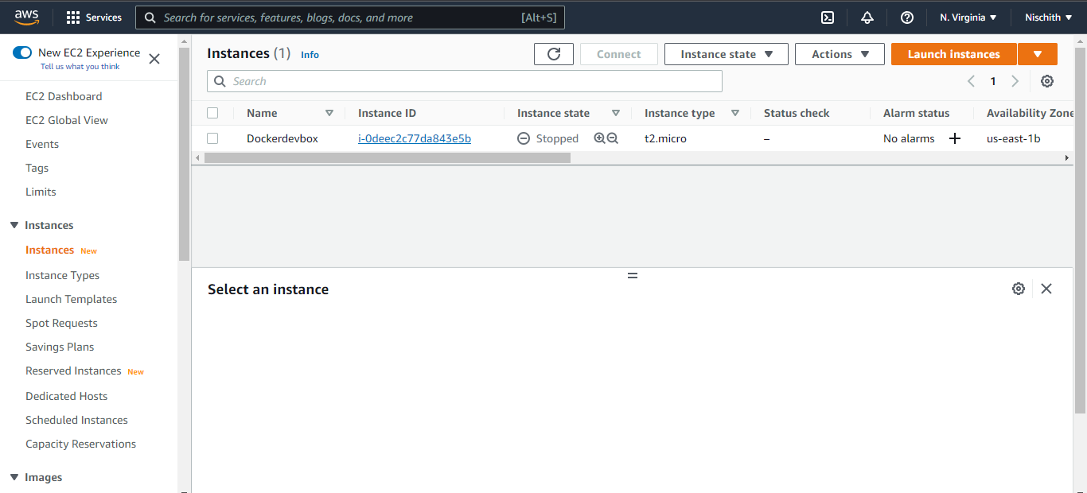

* Then follow 7 steps to create instance

Step1: choose AMI 🡪 Amazon Linux

Step2: choose instance type 🡪 t2.micro

Step3: configure the instance 🡪 select necessary details and click next

Step4: add storage 🡪 add the volume for storage required

Step5: add tags 🡪 give the key and value

Step6: configure security group 🡪 generate new key pair and download it .

Step7: review 🡪 once review the instance and then launch the instance.

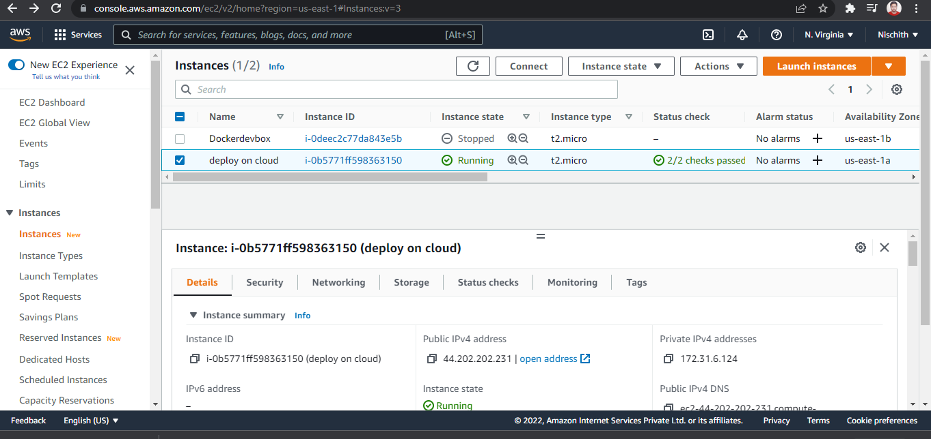

**Step2:** select your angular application and generate the build file using

**ng build --prod**

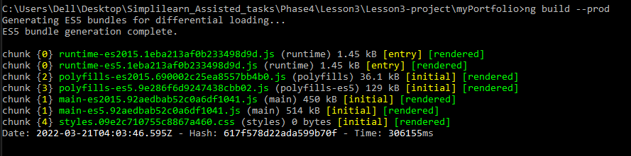

**Step3:** And make that build file to zip file.

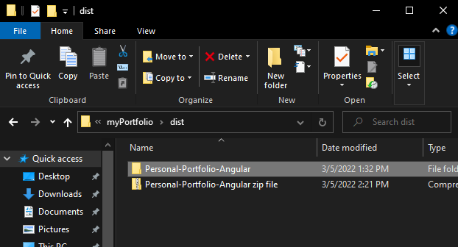

**Step4:** create a bucket in the aws console and add the zip file to it.

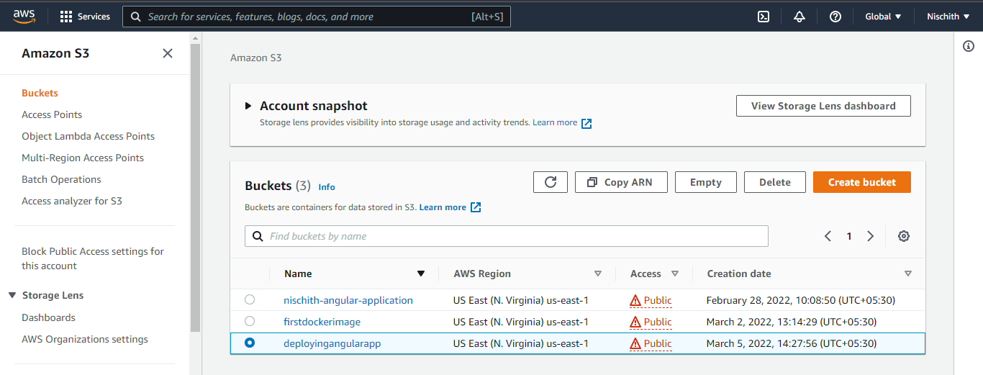



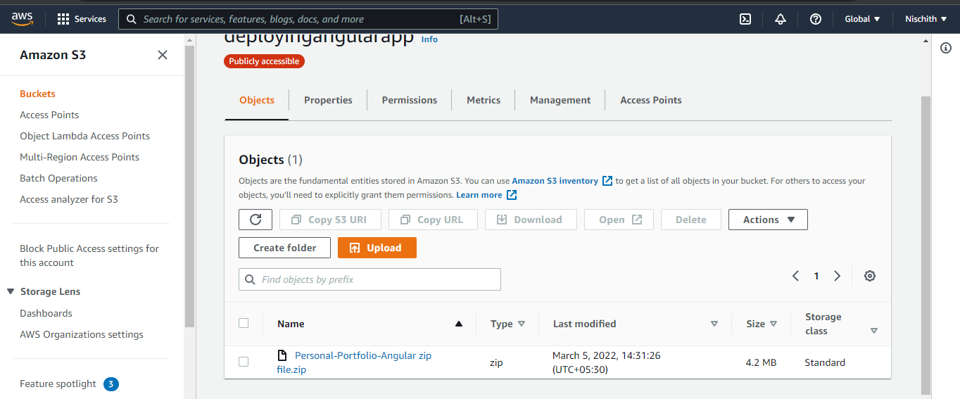

**Step5:** Assign the s3 read only IAM role to the instance so that user can able to download the file from the S3 bucket.

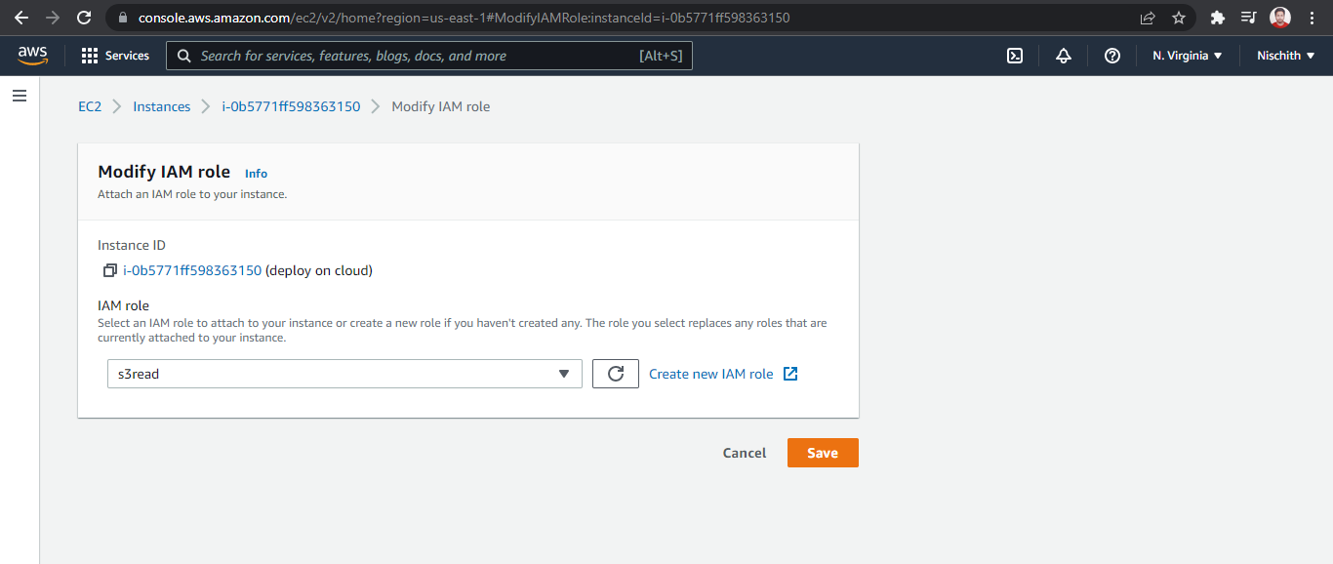

**Step6:** open the ec2 instance in the linux terminal mode.

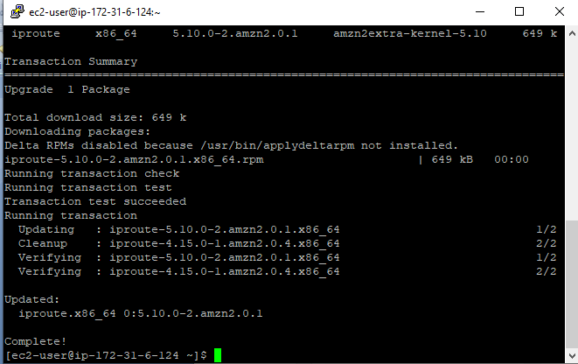

* run this command to install the zip file

$ aws s3 cp s3://deployingangularapp/Personal-Portfolio-Angular.zip .

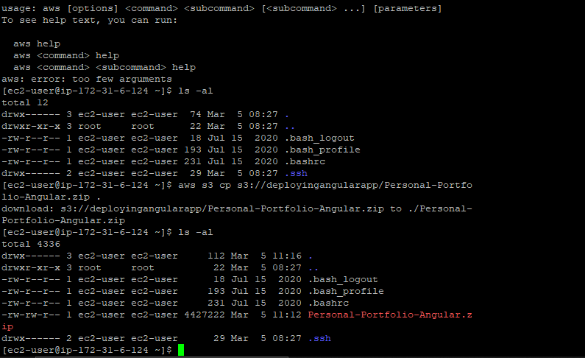

* to unzip:

$ unzip Personal-Portfolio-Angular.zip -d /var/www/html

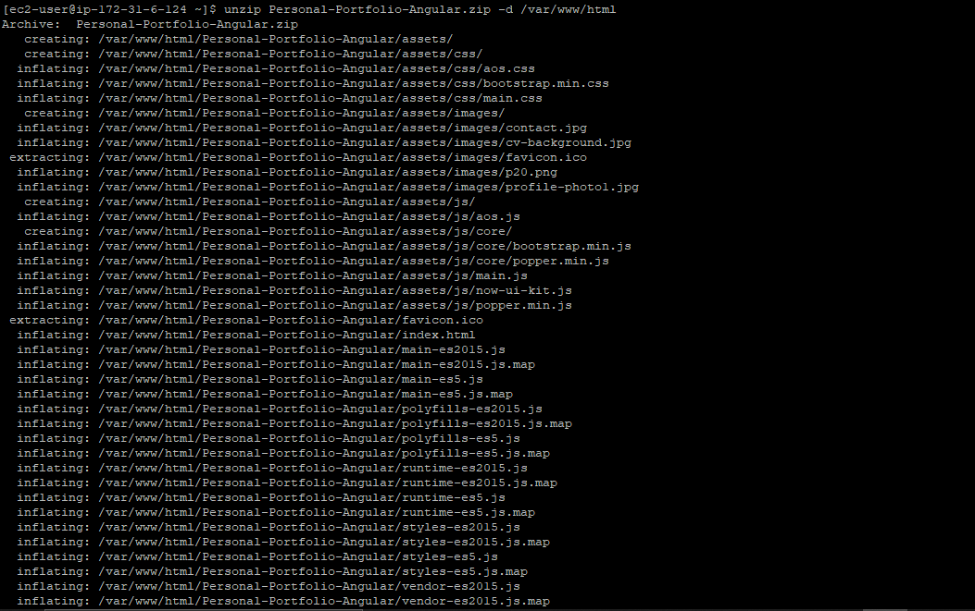

**Step7:** copy the instance public ip address and browse it.

